14 March 2022

Our Reference: | Client Name – Project number | Port Blakely – NZ-7671
Our Reference: | Type of evaluation | Surveillance
Our Reference: | Date of the evaluation: | 13-16 April 2022
Our Reference: | Standard that will be used: | FSC – FSC Accredited National Standard for New Zealand, version 01 of 27 September 2013
Our Contact Details | Contact Person | Carol Rivera
Our Contact Details | Telephone Nr: | +64 278374667
Our Contact Details | Email: | Carol.rivera@sgs.com
Our Contact Details | Postal Address: | 22 Vestey Drive, Mount Wellington 1060
Audit Team | Team Leader: | Carol Rivera
Audit Team | Team member: | Gabriel Araboldi
Dear Stakeholder:
Our client (referenced above) has appointed SGS to carry out an evaluation (on the dates indicated above) of the management of their forests (listed in Annexure A) against the requirements of the applicable Forest Stewardship Council (FSC) Standard mentioned above or

Our client (referenced above) has appointed SGS to carry out an evaluation (on the dates indicated above) of the forest management against the controlled wood requirements of the FSC, with a view to determining whether procedures are in place to ensure that wood supplied as controlled is not from the following categories:
- wood harvested in violation of traditional and civil rights;
- wood which has been harvested from non-FSC-certified forest management units in which high conservation values are threatened by management activities;
- wood harvested from areas being converted form forests and other wooded ecosystem to plantation or non-forest uses;
- wood from forest management unit s in which genetically modified trees are planted.
- illegally harvested wood

We consult key stakeholders to obtain their views on forest management issues relevant to our client and forest practices in the locality.
Your role
You have been identified as an important stakeholder for this evaluation, i.e. an individual, or representative of an organisation, whose views about our client’s forest management need to be taken into account in forming a balanced opinion concerning their overall compliance with the FSC P&C /FSC CW Standards. We would therefore appreciate any comments you might have about forest management practices for the forest lands (appended as Annexure A) under evaluation in relation to their environmental, social and/or economic impacts.
Information on Annexures and enclosures
Attached to this letter you will find the following enclosures:
Annexure A: List of forests included in the scope of the evaluation
Annexure B: Further information on the audit process and your role as a stakeholder.
Stakeholder Report Form: This is a guide to help you reply:
- Please write your comments on this form and return it to the SGS affiliate, using the address or email above, as soon as possible.
- Where relevant your comments will be included in the certification report, but will we will not indicate your name or affiliation.
- All your comments will be kept on file and available for reference.
- Please do not feel restricted by this form; if you have additional comments please append them.
- Note that any comments supported by objective evidence will take on a much greater significance.
- We would also appreciate any comment you may have on the usefulness of the form itself.
Additional Information that is available
To further assist you with your role in the certification process, the following additional information and/or documentation can be made available on request:
- A list of all the FSC certificates issued by SGS can be accessed on the FSC website info.fsc.org;
- A summary of forest management and/or Chain of Custody certification, explaining the objectives and processes involved is available, The SGS Code of Practice and SGS General Conditions for Services, outlines the agreement between SGS and the certificate holder or prospective certificate holder and the SGS procedures for the handling of complaints and appeals are available in the SGS webpage – www.sgs.com/forestry. If you need the documents you can also request them from the local SGS office.
Your response
We would be most grateful if you would take some time to read Annexure B, fill in the Stakeholder Report Form and return it to us as soon as possible together with any other comments you may have. If we have not received your reply within 6 weeks of the date that appears at the top of the form, we will assume that you do not wish to participate in the process. You are however, welcome to participate at any time during the period of certificate validity and your comments and input will be considered during future surveillance evaluations. It will also be appreciated if you could provide us with the names and contact details of stakeholders that we should include in our list.
Our actions
Depending on the issues you raise and their possible impact on the outcome of this certification, we may contact you for a meeting or a telephone interview during the course of the evaluation. If so, we will attempt to arrange a suitable time as soon as possible after we receive your reply. SGS also has a formal procedure for resolving any disputes and this can be made available to you on request or in SGS website
Please also note: Your identity will not be disclosed to anyone outside SGS (which includes persons sub-contracted to perform the evaluation), staff of the FSC International Centre and Assurance Services International (ASI). All such persons have signed confidentiality agreements.
Should a certificate be issues, the evaluation results (including any comments received from stakeholders), will be publicly available through a summary report on the website, info.fsc.org
Thank you very much for your assistance.
Yours sincerely,
SGS
Annexure A
List of Forest Management Areas Included in the Scope

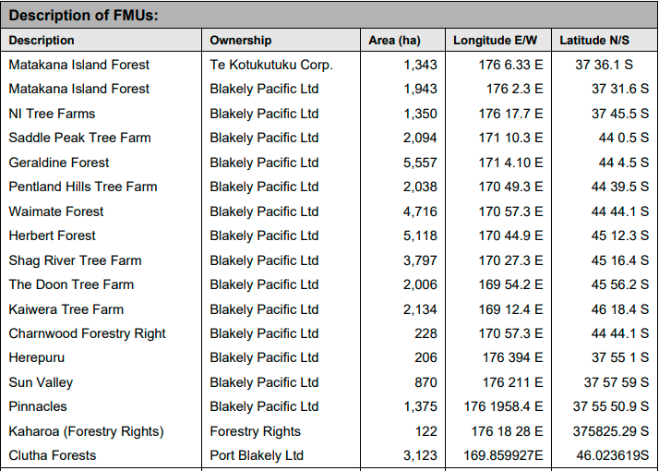
Annexure B
Stakeholder Briefing Note
- INTRODUCTION
This note aims to provide information for people who are involved in, or affected by, the management of a forest, which is being assessed by SGS
- What is forest certification?
Forests provide a wide range of products and services. Forests have important environmental functions, such as preserving soil and water resources. They may be essential for the livelihoods of rural communities who rely on forests for meat, fish, medicines or other products. They also support the forest industry, which provides jobs and income in rural areas and government revenues.
Forest certification is a process of assessing and identifying well-managed forests, where management is environmentally sound, socially beneficial and economically viable.
Products which come from a certified forest area, may carry a label identifying them as coming from a well-managed source. This provides reassurance to consumers, retailers, governments and investors. Major retail outlets in Europe, North America and elsewhere have committed themselves to specifically marketing wood and wood products, originating from well-managed forests.
- What is the Forest Stewardship Council™?
The Forest Stewardship Council™(FSC™) is an independent, non-profit, non-governmental organisation. It was founded in 1993 by a diverse group of representatives from 25 countries worldwide, including environmental and social groups, the timber trade and the forestry profession.
The FSC has developed a set of Principles and Criteria of Forest Management (P&C) which define good forest management. Forests whose management is independently assessed as complying with the P&C can be certified as ‘well-managed’. All certifications to FSC standards must involve local, national and international stakeholders. This includes people who are involved in, or affected by, forest management: people who live in or near forests; people concerned by environmental or social issues to do with forests; people who work in forestry; and many others.
- SGS and the Forest management certification Programme
Forest certification against the FSC P&C is carried out by certification bodies. To make sure that evaluations are carried out consistently and that the certificates are credible, certification organisations are accredited and monitored by the FSC.
SGS is the world’s largest inspection and verification organisation. SGS has a forest certification programme, which has been accredited by the FSC through ASI. The SGS Forest Management programme is globally accredited
- Summary of the forest management Evaluation Process
A Forest management evaluation has the following phases:
- Pre-evaluation: This is a brief visit to the forest area by an FM assessor. Major gaps between the current management and the requirements for certification are identified. Most pre evaluations are voluntary and in some specific cases (according to the scale, forestry type and others) it will be compulsory
- Local standards development and stakeholder consultation (Not applicable in case of CW) National Forestry Standards approved by FSC are used in the assessment. National and local codes of practice, legislation and guidelines are examined and incorporated into the FM SGS Local generic standards in case of the absence of the FSC National Standard approved. The current SGS FM Generic standard is permanently available on our website and the local standard that will be used in this evaluation will be made available on the website, or hardcopy, if so requested.
- A range of stakeholders is contacted to obtain their views and comments on the documents used for the local standard and about the forest management operations. Any other documents suggested by stakeholders will be studied. Where stakeholders wish to discuss issues, arrangements are made to meet with the SGS assessors during the main evaluation. All major issues raised by stakeholders must be addressed before certification can continue. Any comments/information received will be handled in confidence and the identity of stakeholders that do participate in this process will not be made known to the organisation that is being assessed nor in the public summary, that SGS Qualifor will publish if a positive certification decision is made.
- Main evaluation SGS assessors, assisted by local technical specialists, visit the forest. Forest management operations are assessed for compliance with the local standard. Forest management documentation, such as the forest management plan and operational procedures is reviewed. Field operations are audited by visiting a random selection of sites. At the end of the main evaluation, the SGS audit team decides whether to recommend the forest management for certification.
- Peer review: (Not applicable in case of CW) A report describing the evaluation and results is sent to one to two independent peer reviewers (determined by the size of the operations that are being certified) who are recognised and respected in their fields. The peer reviewers check the evaluation team’s methods and conclusions and endorse the recommendation if appropriate.
- Certification and surveillance If the result of the evaluation is positive, SGS awards a certificate. A summary of the report is made publicly available and a programme of regular surveillance is begun. Stakeholders can raise issues at any time by contacting SGS.
- Why is SGS CONTACTING you?
We have started the consultation of stakeholders about the forest area described in the covering letter. We would like to know:
- your views on the documents we are using in developing the local standard; and
- any comments, issues or information we should take into account when assessing the forest management operations.
We have attached a form which can be filled in, but please feel free to send other information. It is very helpful if you can provide objective evidence to back up any points you raise: for example, a claim that “Company X has a very bad safety record” could be supported by facts such as the approximate dates of recent accidents and details of what happened. We may contact you if further clarification is necessary.
- How will your comments be CONSIDERED in this process
All comments received from stakeholders will be recorded in the Public Summary of the certification evaluation, but your identity will not be revealed. A copy of this report can be obtained from the website http://info.fsc.org or you may request a hardcopy of this by contacting the Programme Director at the address given at the bottom of the first page.
Two final points:
First, if you have any positive things to say about the forest management, please let us know about these too.
Second, if you know of any important stakeholders whom you think should be contacted, then please let us know.

Many thanks for your help

